McDonald’s

Table of Contents
Background …………………………………………………………………………………..… 3
Ratio Analysis ……………………………………………………………………………….…. 4
Common Size Analysis …………………………………………………………………….…. 7
Conclusion………………………………………………………………………………………. 9
Works Cited …………………………………………………………………………………..... 10

Background:
McDonald’s is one of if not the most recognizable brand in the world. The fast food joint from San Bernardino, California originally specialized in barbeque but later shortened their menu to only include burgers, fries, milkshakes and other fast food items. Dick and Mac McDonald’s (the original founders) new empire expanded internationally in 1967, just 27 years after the first restaurant was created when they opened. Currently they operate in over 100 countries. The brand’s market capitalization currently resides at a little over $200 billion and they own the 5th most land of any company in the world. With iconic menu items like the Filet-O-Fish and Big Mac, the brand has become a mainstay in American culture and is widely recognizable almost anywhere in the world.

Wendy's was created by Dave Thomas and he opened his first restaurant on November 15, 1969 in Columbus, Ohio. The company is credited with introducing drive through windows which revolutionized the fast food industry. The chain became a publicly traded company in 1976 when they issued 1 million shares of common stock. The business has won many awards for their rapid growth, including being named the stock of the year in 2013 by Yahoo! Finance. The restaurant’s net worth currently resides at $1.3 billion. With over 7,000 locations, Wendy’s has quickly expanded their influence across the globe.

Shake Shack was started by Danny Mayer in 2001 and started off as a temporary hot dog stand. The hot dog cart started to gain lots of traction and was becoming a fan favorite in the area so in 2004 he turned the cart into a permanent kiosk style fast food restaurant. They are known for their hamburgers, hot dogs, french fries, and milkshakes. They went public in 2015 where they saw a stock price increase of 124% on the first day. Today there are 377 different Shake Shack locations, they employ over 7000 people and they have a total revenue of around 739.9 million dollars.

A current event that is going on with McDonald’s is that they just hired a new Chief Impact Officer and a new Global Chief Communications Officer. Their new CIO will be Kathy Baird. She will be working on impact strategy, overseeing teams responsible for enhancing and protecting the McDonald’s brand across state and local government relations. She will work on increasing leadership across the company. Their new GCCO will be Anne Hammer. Her responsibilities will be focused on elevating and protecting the brand and driving growth for the business through compelling, impactful storytelling. She is going to help the company get and keep a good culture.

Ratio Analysis:
Current and Quick Ratio
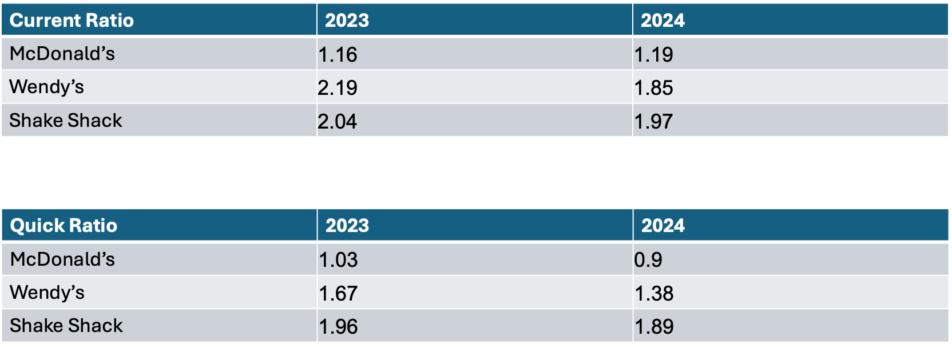
The current and quick ratio measure a company’s ability to cover short-term obligations. For these two ratios, above 1.0 shows sufficient liquidity to cover current liabilities the company may have. More specifically, the current ratio is a company’s ability to pay off its short term liabilities and produce cash while including all current assets. McDonald’s keeps a low current ratio which aligns with its reliance on franchise revenues. Staying close, but above 1.0 shows that McDonald’s has effective working capital management, meaning the revenues are quickly moved towards growth, equipment, or other activities of value. There was a small increase from 2023 to 2024 that shows a steady working capital even with the increase in inflation during that time. Wendy’s ratio declined from 2.19 to 1.85, indicating higher amounts of short-term obligations. This can mean they increased reinvestment numbers and or increased support for franchises. Shake Shack had a slight decrease, but still remains around the 2.0 mark. This number shows they take a more reserved stance and keep a healthy amount of current assets. As McDonald’s is such an established company, it allows them to operate with a much leaner liquidity due to their extremely consistent and historic cash inflows. While on the other hand, Wendy’s and Shake Shack have to maintain higher liquidity buffers in order to manage their operational risks and growth requirements.

McDonald’s quick ratio slightly declined from 1.03 to 0.90, showing that their liquid assets dipped under what is considered sufficient to pay back short-term liabilities. McDonald’s is not worried about this, as it is a multi-billion dollar company. With that being said, the quick ratio decreased due to the company inserting more cash into shareholder returns and investments into technology. Wendy’s fell from 1.67 to 1.38 which matches the current ratio decline, aligning with their reinvestment activities and decreased cash reserves. Shake Shack’s quick ratio also slightly decreased from 1.96 to 1.89, still high amounts of liquidity. In comparison, Shake Shake demonstrates the highest amount of liquidity which checks out due to its less established place in the market. McDonald’s is a prime example of how a massive company can manage liquidity with minimal amounts of assets in reserve. Wendy’s fits right in between as a moderate example in every category.
Debt-to-Equity Ratio and Leverage Ratio
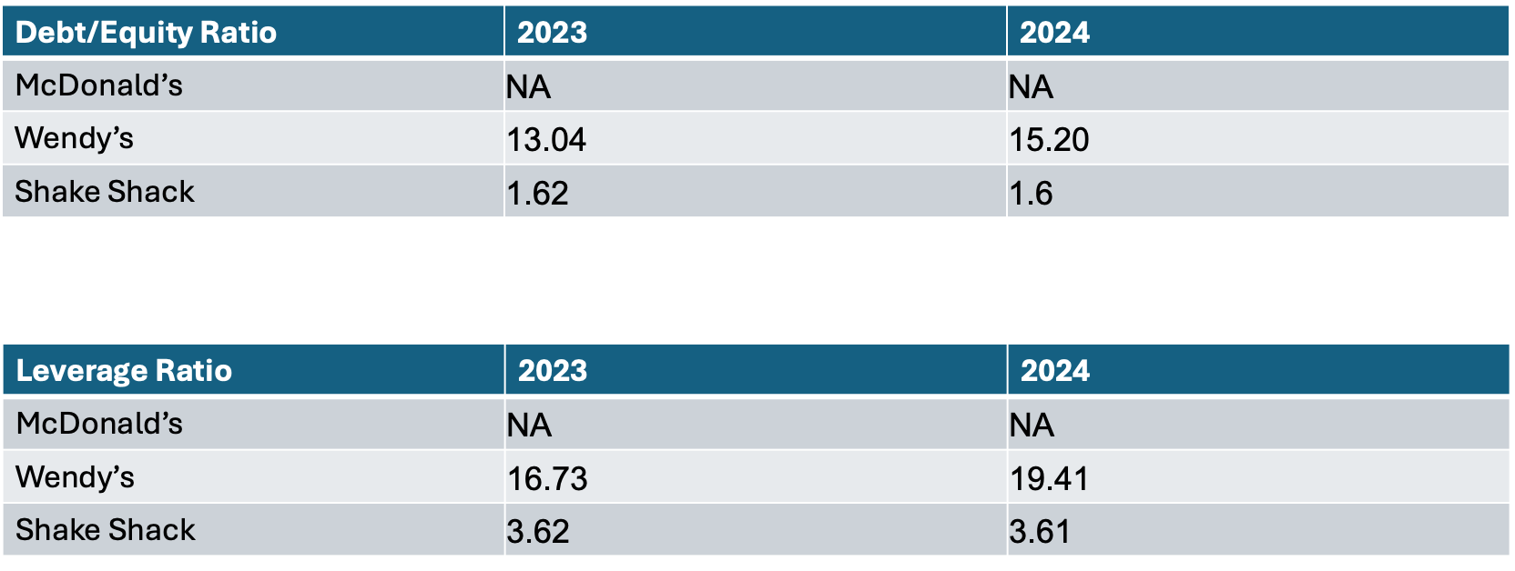

The debt-to-equity ratio is measuring the amount of liabilities and debt a company has taken compared to the assets with liabilities taken out. A high dent to equity ratio means that a company has taken out a lot of debt to finance what it is doing compared to a low debt-to-equity ratio which means they are relying more equity to finance the business. McDonald's information for debt/equity ratio is unavailable. Wendy's had a 16.73 debt/equity ratio in 2023 and a 19.41 debt/equity ratio in 2024. This shows that they have a lot of debt and rely on debt to finance their business expenditures. There was a jump of 2.16 from 2023 to 2024. This shows that Wendy’s increased its reliance on debt to fund itself compared to the year before. Shake Shack had a debt/equity ratio of 1.62 in 2023 and a 1.6 in 2024. This shows us that Shake Shack doesn’t rely too heavily on debt to finance their company and that they rely more on equity to finance their company. There was a decrease of 0.2 from 2023 to 2024. This means that in 2024 Shake Shack used less debt to finance their company compared to 2023 but it was a very small amount.

The leverage ratio is used to determine the relationship between the company debt and assets and help indicate risk. A high leverage ratio means that a company has a lot of debt so it could be at risk due to the fact they need to pay it off. McDonald's doesn’t have any information available. Wendy's had a leverage ratio of 16.73 in 2023 and 19.41 in 2024. This shows that they have a nigh leverage ratio which means they have a lot of debt which can also be seen in their debt/equity ratio. It also shows that they are being riskier by supporting themselves through debt. This also shows an increase of 2.68 which shows they increased their use of debt and are being riskier. Shake shake had a leverage ratio of 3.62 in 2023 and 3.62 in 2024. This shows that they have a lower level of reliance on debt which is consistent with their debt/equity ratio. This also shows that they risk less by not going into as much debt as other companies. We can see a decrease of .01 from 2023 to 2024. While it is a very small decrease it still is a decrease. This means that they have taken on less debt and they are risking less than the year prior.

Return on Equity and Return on Assets
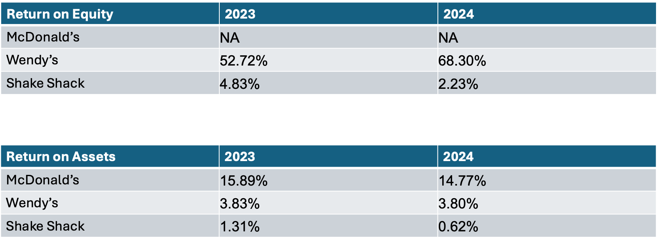
Return on equity measures a company’s profitability when it comes to generating income for shareholders’ equity. Wendy’s ROE increased from 52.72% in 2023 to 68.30% in 2024, showing improved efficiency and profitability. On the other hand, Shake Shack saw a decrease from 4.83% to 2.23%, indicating a decrease in efficiency converting equity into profits. McDonald’s ROE data was unavailable for both years not allowing us to compare it to the other companies. Further research shows that McDonald’s actually operates with a negative ROE, deciding to return almost all its cash to shareholders, but the number in not disclosed.

Return on assets measures how effectively a company uses its assets to create profits. McDonald’s held the highest ROA both years, only suffering a slight decrease from 15.89% in 2023 to 14.77% in 2024. Wendy’s operates at a much smaller ROA, but similarly faced a minor decrease of just 0.03%. Shake Shack’s ROA dropped from 1.31% to 0.62% signaling noticeably reduced profits generated when is comes to assets. Like many other categories explored, McDonald’s remains the most efficient, while Shake Shack faced the greatest decline for the year.

Earnings Per Share and Price to Earnings Ratio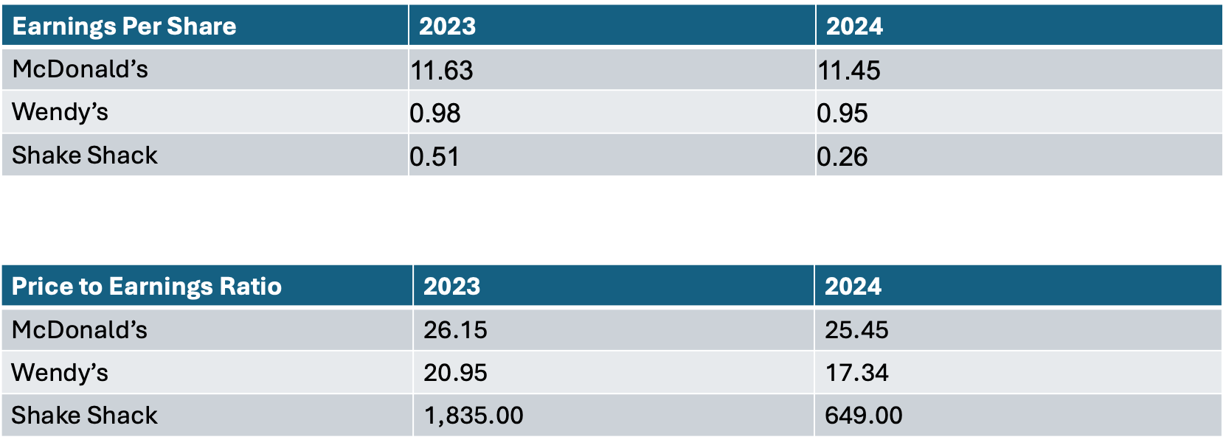

Earnings per share is a measure of the company's overall profitability, showing how much of its net income is allocated to each share of common stock. Price to earnings per share is a metric that calculates how much investors are willing to pay for every dollar of the company's earnings. McDonald’s holds a high EPS level, showing a minor decline in 2024 due to post pandemic margins normalizing. Wendy’s follows a similar pattern with the ratio slightly decreasing from 2023 to 2024. Shake Shack experienced a much larger drop off as it cut its ratio in half. This can be connected to a struggle to grow and scale business when costs were rising during this time. McDonald’s and Wendy’s were able to maintain stable and predictable earnings as they have much more established operations. McDonald’s and Wendy’s both experienced slight declines in their P/E ratios going from 26.15 to 25.45 and 20.95 to 17.34, showing reduced investor confidence and or the expanded growth to be slower. Shake Shack showed and extreme P/E ratio of 1,835 in 2023 and then a major drop to 649 in 2024. This can be suggestive to investors reevaluating the company and correcting expectations to match the times.
Even with the drop, Shake Shack holds a very high P/E ratio which indicates that investors are optimistic towards the company’s future.

Common analysis:
Balance Sheet Common Size
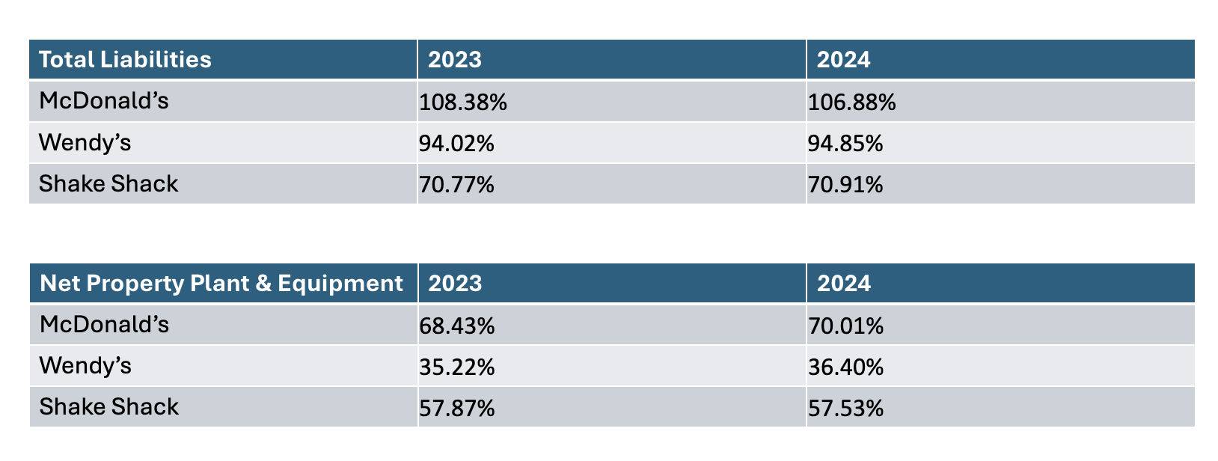
Looking at each company’s total liabilities, this percentage focuses on analyzing how much of the company is made up of liabilities which are based on total assets for the year. Overall, it shows how much of the company’s assets are currently being funded by debt. For Mcdonalds, their total liabilities were 108.38% in 2023 which dropped to 106.88% in 2024. Although the drop in percentage is small the company is still happy to see improvement over the year. On the other hand Wendy’s had smaller liabilities than Mcdonalds but still a solid number at 94.02% in 2023 and 94.85% in 2024. These numbers are considered to be pretty steady due to the small number of changes over the year. Finally Shake Shack had the lowest levels of liabilities at 70.77% in 2023 and 70.91% in 2024. These numbers show a more even level between debt and equity within the company. With Shake Shacks numbers being lower than Mcdonald’s and Wendy’s numbers it suggests that Shake Shack’s assets are funded primarily through equity which is the opposite of Mcdonald’s and Wendy’s.

Following Total Liabilities we have Property, Plant, and Equipment also known as PPE. PPE how much of a company's assets are long-term or tangible assets. To start, Mcdonald’s numbers are high at 68.43% in 2023 and 70.01% in 2024. The small increase shows that the company is trying to make strides towards having longer term assets which are also physical assets such as land or equipment. Next we have Wendy’s which have much lower PPE percentages coming in at about half of McDonald’s. Wendy’s percentages came in at 35.22% in 2023 and 36.40% in 2024. Although the numbers are low Wendy’s also showed a liking to expanding their physical assets. Finally we have Shake Shack which came right in between the first two companies at 57.87% in 2023 and 57.53% in 2024.

Income Statement Common Size
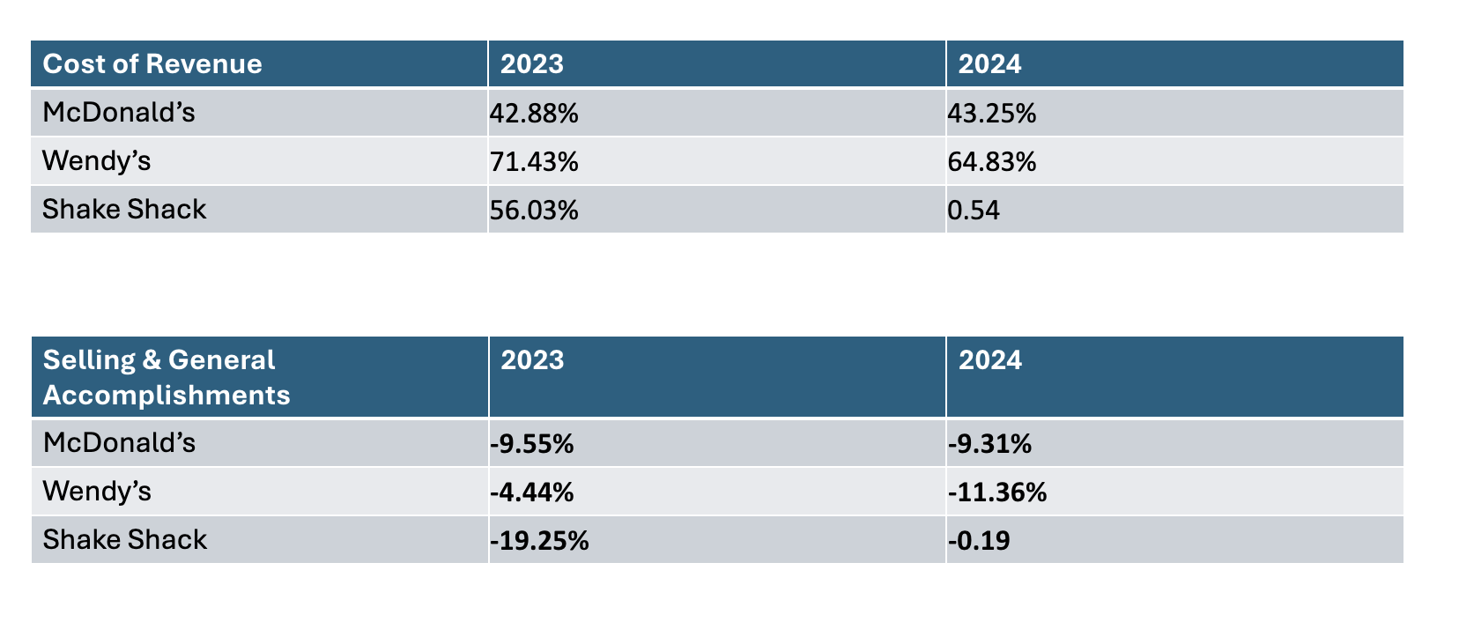
Next we are moving on to Cost Revenue which is the percentage based on the cost of revenue divided by total revenue. The job of Cost revenue is to measure the efficiency between expense and sales. McDonald's as we can see had a lower Cost Revenue at 42.88% in 2023 and 43.25% in 2024. The small change we see in percentage shows stability within the company. On the other hand, Wendy’s had much higher percentages at 71.43% in 2023 and 64.83% in 2024. The numbers are higher than usual but the percentage drop shows improvement in the cost management department which is always positive. Finally we have Shake Shack who showed a drastic switch in percentages from year to year coming in at 56.03% in 2023 and 0.54% in 2024. This massive shift makes it hard to tell what is happening within the company but it could be due to things such as operational adjustments throughout the year.
To wrap it up we will be looking at selling, general, and administrative expenses also known as SG&A. SG&A measures how much of the company’s revenue is consumed by general operations. To start, McDonald's percentages were stable at -9.55% in 2023 and -9.31% in 2024. The little change from year to year shows that they have strong expense control. Next Wendy’s SG&A rose from -4.44% in 2023 to -11.36% in 2024. This rise could possibly be due to marketing expenditures. Finally we have Shack Shack, who showed a massive drop from -19.25% in 2023 to just -0.19% in 2024. The massive drop in percentage could indicate that the company is focusing on cost efficiency. McDonald’s definitely had the best cost control while Shake Shack leans towards improving on being efficient.

Conclusion:

To sum things up, McDonald’s continues to prove why it is a global industry leader in the fast-food space. Through our research using Morningstar it thoroughly shows a strong, steady foundation supported by consistent revenue streams, efficient operations, and leveraging debt for strong long-term investments. Their ability to keep a current ratio around the 1.0 mark illustrates how intelligent and superior their working capital management is, illustrating that they don’t need excess cash to expand and be stable. Compared to Wendy’s and Shake Shack, McDonalds demonstrates more control and confidence in operations.

While specific debt-to-equity ratios were not available, it was obvious McDonald’s has built a structure that balances debt with long-term assets and stability. Wendy’s shows a heavier reliance on debt and Shake Shack seems to play it safe. Which in the grand scheme of things does make sense as McDonalds is in a global market, while Wendy’s is trying to play catch up, and Shake Shack is relatively new in the fast-food world.

Profitability wise, McDonalds continues to lead the pack. Even after the margin normalization from COVID, McDonald's EPS remains strong and consistent. Through this stability with a global shutdown it shows investors how strong of a stock they are investing in, as analysts would call it a “blue chip stock”. Although Wendy's is starting to carve their own path and improve their ROE they have yet to earn the status of “blue chip” and Shake Shack had a decent-sized dip highlighting they may be facing challenges, often occurring when newer brands try to scale up.

From the common-size analysis, McDonald’s high PP&E illustrates that they invest in long term assets. Some of these assets may be land, buildings and kitchen equipment. On top of that their SG&A cost stays consistent each year showing stability and consistency year to year. Unlike Wendy’s where they have had a massive upswing from 2023 to 2024 and Shake Shack’s numbers already being so high.

In short, we believe it is safe to say McDonald’s stands out as the most financially stable and strategically positioned company among the three. Their efficient use of assets, strong profitability, and growth make them not only the top brand in fast-food but an industry leader as no other company comes close to competing with them. Similar to Coke and Pepsi, usually there are a few competitors, but in this instance McDonald’s is Coke and there is no Pepsi.

Works Cited

Fernando, Jason. “Debt-to-Equity (D/E) Ratio Formula and How to Interpret It.” Investopedia, Investopedia, www.investopedia.com/terms/d/debtequityratio.asp. Accessed 15 Oct. 2025.
Hayes, Adam. “Shake Shack’s Rise: From Hot Dog Stand to Global Fast-Food Phenomenon.” Investopedia, Investopedia, www.investopedia.com/articles/personal-finance/041615/story-behind-shake-shacks-success.asp. Accessed 15 Oct. 2025.
Hayes, Adam. “Leverage Ratio: What It Is, What It Tells You, and How to Calculate.” Investopedia, Investopedia, www.investopedia.com/terms/l/leverageratio.asp. Accessed 15 Oct. 2025.
The Wendy’s Story: Wendy’s.” The Wendy’s Story | Wendy’s, 1 Nov. 1969, www.wendys.com/wendys-story.
“Welcoming New Global Impact Leadership Team Members.” McDonald's Corporate, 12 Sept. 2025, corporate.mcdonalds.com/corpmcd/our-stories/article/mcd-leadership-update-kathybaird-annehammer.html.

